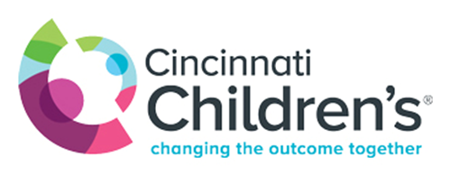

The University of Cincinnati College of Medicine and Cincinnati Children’s Hospital Medical Center has a commitment to diversity and inclusion among our students, residents and faculty. One of our diversity goals is to increase racial and ethnic diversity reflecting the population of the Cincinnati and surrounding community that we serve. To that end, the Office of Diversity and Inclusion is now sponsoring the University of Cincinnati and Cincinnati Children’s Underrepresented in Medicine Visiting Clerkship Program. We will sponsor up to 12 funded visiting clerkship positions, space permitting, available from July through October for applicants from backgrounds underrepresented in medicine. This program will provide a stipend up to $1000, to help defray the cost of an away rotation, to 4th year medical students attending a U.S. medical school from backgrounds that are underrepresented in medicine including Black/African American, Hispanic/Latino, Native American/Alaska Native, and Native Hawaiian/Pacific Islander.

Our program includes a 4-week clinical rotation in the departments of Anesthesia, Emergency Medicine, Family Medicine, General Surgery, Internal Medicine, Neurology, Ophthalmology, Orthopaedic Surgery, Radiation Oncology, Pathology, Pediatrics and Psychiatry. You will also be connected to members of our minority housestaff association for social events and networking opportunities.

Applicants must complete the VSAS application at https://services.aamc.org/20/vsas/ and the attached supplemental application. Preference for rotation experiences will be given first to University of Cincinnati College of Medicine students so there is a chance that the department may be full during the month you select to visit. Applicants are encouraged to apply to multiple options and rotation dates.
All application materials must be submitted via VSAS in addition to The Underrepresented in Medicine Visiting Clerkship Program supplemental stipend application. The supplemental application and inquiries should be sent directly to uccomodi@ucmail.uc.edu
Acceptance to the visiting program is contingent upon acceptance to the Visiting Student Program for a U.S. applicant. You will not be guaranteed an interview to the program of your choice based on your participation in our program
The deadline for the application submission is May 15th.

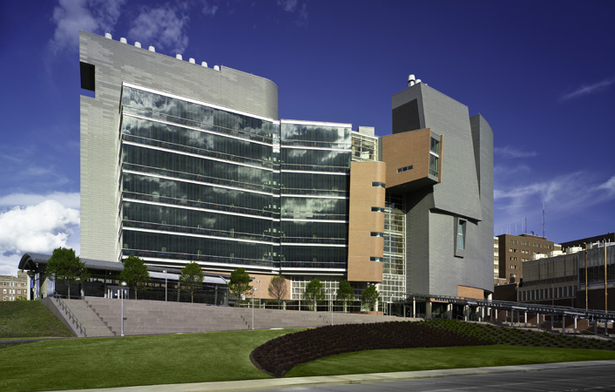

University of Cincinnati College of Medicine Underrepresented in Medicine Visiting Clerkship Program
2018-2019 Supplemental Stipend Application

Last Name: ________________________________First Name: ____________________________
Email address: _____________________________Phone number: _________________________
Medical School: ___________________________ Expected Grad. Date ___________________
Birth place: _______________________________Date of birth: ________________ (mm/dd/yy)
Gender: __________________________________Race/Ethnicity_______________________________
What city & state do you call home? ______________
Residency program interest: _____________________________________________
USMLE Step 1 Score (please attach a copy of the score report) __________________________________

How did you hear about the program?

_________________________________________________________________________________
_________________________________________________________________________________

Please briefly tell us why you are interested in this opportunity at the University of Cincinnati and Cincinnati Children’s.
_______________________________________________________________________________________________________________________________________________________________________________________________________________________________________________________________
____________________________________________________________________________________________________________________________________________________________________________________________________________________________________________________________________________________________________________________________________________________
_____________________________________________________________________________________
Please briefly describe any ties to the Midwest.
__________________________________________________________________________________________________________________________________________________________________________
_______________________________________________________________________________________________________________________________________________________________________________________________________________________________________________________________
__________________________________________________________________________________________________________________________________________________________________________
Please describe any contributions you have made in support of your racial, ethnic or gender group.
_________________________________________________________________________________________________________________________________________________________________________________________________________________________________________________________________________________________________________________________________________________________________________________________________________________________________________
_____________________________________________________________________________________
_____________________________________________________________________________________
_____________________________________________________________________________________

Signed: ________________________________________________________Date:_____________

